Slide 1 DriverPass System Analysis
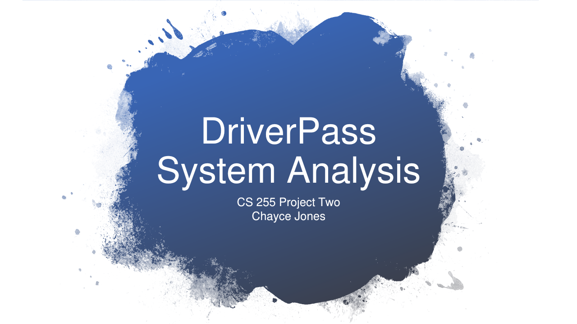

Speaker Notes
The main goal of this system is to give DriverPass one place to manage its training services. Customers would be able to schedule driving lessons and keep track of their progress. Customers with Package Three would also have access to online classes and practice tests. The secretary could help customers who call or come into the office. I think keeping this information together would make it easier for staff to manage appointments and help customers prepare for their DMV tests. These slides explain how the system would work and what DriverPass would need to consider.
Source: CS 255 DriverPass Interview Transcript, DriverPass Interview section.

Slide 2 System Requirements
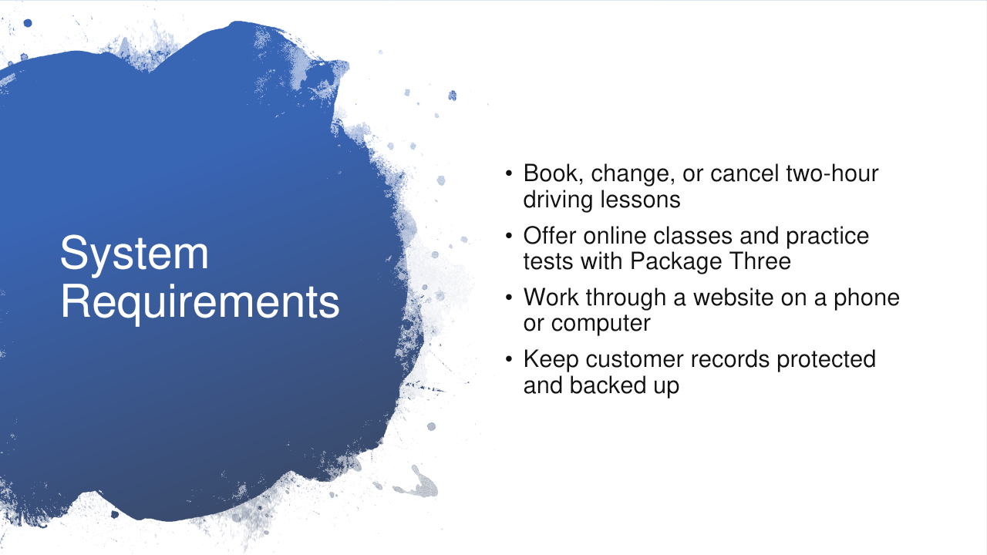

Speaker Notes
The system needs to let customers and the secretary book, change, or cancel driving lessons. Each lesson lasts two hours, so the system would check that the customer has enough hours left in their package. It would also check that a driver and car are available before confirming the appointment. This would help prevent double bookings. Package One includes six driving hours. Package Two includes eight driving hours and an in-person rules lesson. Package Three includes twelve driving hours, the rules lesson, and online classes with practice tests. Customers could check their test scores and see where they need more practice. The website would work on a phone or computer, and a cloud provider would handle hosting and backups.
Source: CS 255 DriverPass Interview Transcript, Reservations, packages, online progress, interface, and cloud hosting discussion.

Slide 3 Use Case Diagram
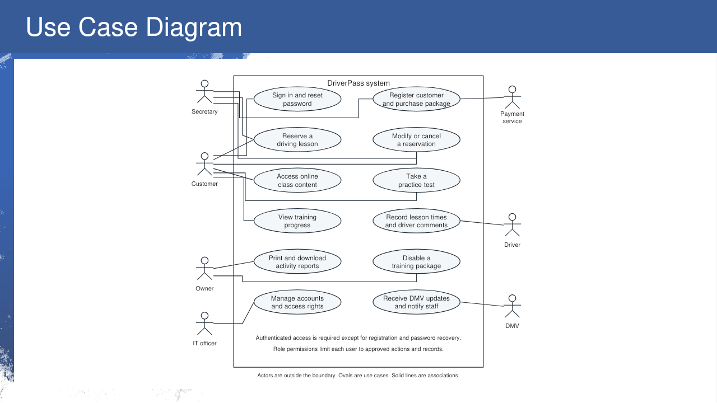

Speaker Notes
This diagram shows the different people who would use the system and what each person can do. The people are outside the large box, and the tasks are inside it. Customers can schedule lessons and view their progress. The secretary can register customers and make reservations for them. Drivers can record lesson times and leave comments about how the customer did. Liam, the owner, can review reports and stop new purchases of a training package. Ian, the IT officer, can manage accounts and control access. The DMV is shown because DriverPass needs to keep its training information current. I also included a payment service as a design recommendation for processing card payments. Each person would only have access to the information needed for their role.
Source: CS 255 DriverPass Interview Transcript, Users, security, reservations, packages, and DMV updates discussion. The payment service is a proposed design choice.

Slide 4 Activity Diagram
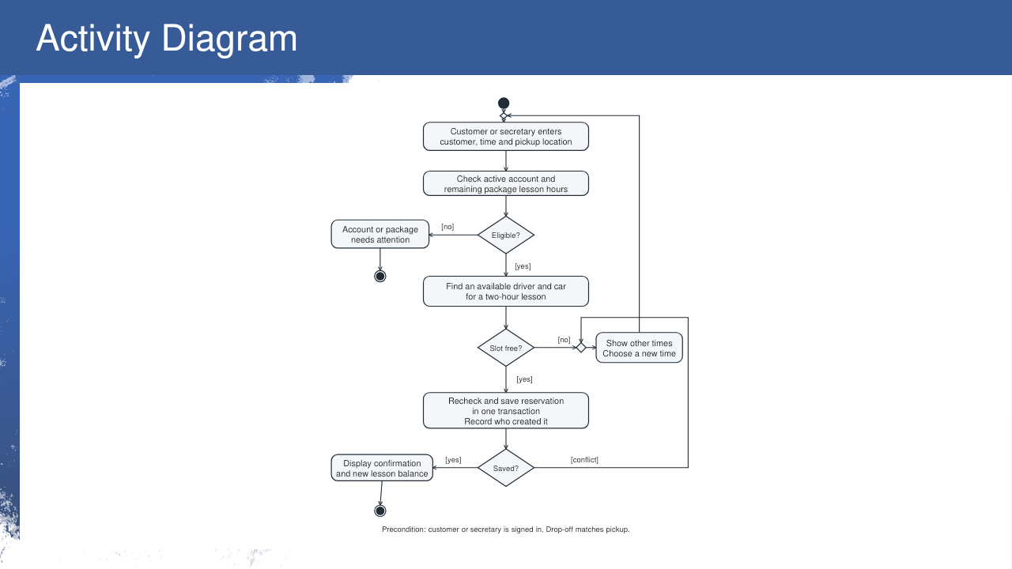

Speaker Notes
This diagram shows the steps for reserving a driving lesson. First, the customer or secretary enters the requested time and pickup location. The system checks that the account is active and that the customer has enough lesson hours left. If something needs attention, the system lets the user know before continuing. It then checks whether a driver and car are available for the full two-hour lesson. If that time is already taken, the user can choose another time. The system checks availability again before saving the reservation. This helps prevent two customers from booking the same driver or car at the same time. Once the reservation is saved, the customer sees a confirmation and their updated lesson balance. The system also records who made the reservation. The drop-off location matches the pickup location.
Source: CS 255 DriverPass Interview Transcript, Reservations and registration discussion.

Slide 5 Security
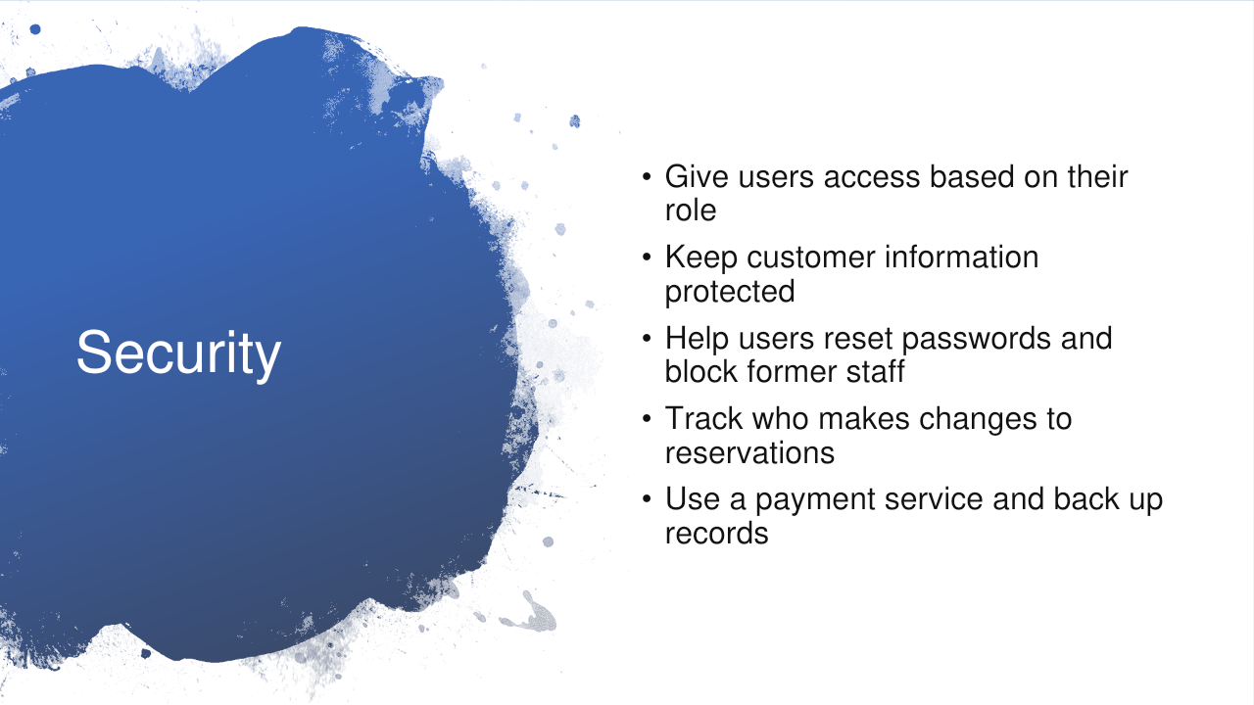

Speaker Notes
Security is important because the system stores customer information and training records. Customers would be able to see their own information, while staff would have access based on their job. Ian could help reset accounts and block former employees from signing in. The system would also provide a secure way for customers to recover a forgotten password. It would protect information both when it is stored and when someone sends it through the website. The reservation history would show who made a change and when it happened, which would help Liam look into scheduling problems. I recommend using a separate payment service to handle card information and keeping backups so records can be restored after a problem. DriverPass would still need to keep employee access up to date.
Source: CS 255 DriverPass Interview Transcript, Security, tracking, registration, and cloud hosting discussion. Specific protection and payment handling choices are design recommendations.

Slide 6 System Limitations
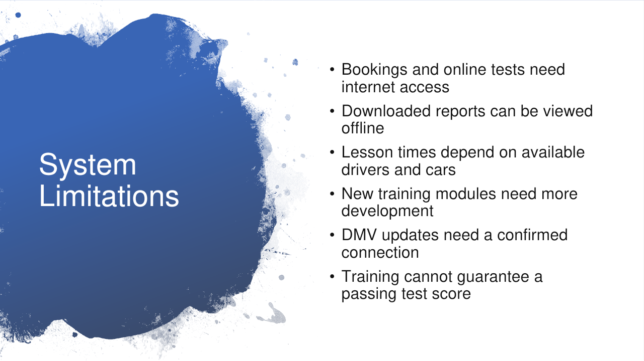

Speaker Notes
The system has a few limitations that DriverPass would need to plan for. Customers and staff need an internet connection to save reservations, update records, or use online tests. Liam can download reports and view them offline, but those copies would not update the live system. Scheduling also depends on the available drivers and the ten cars described in the interview. The first version would support the three current packages and let Liam disable a package. Adding new training modules would take more development. The interview does not explain how the DMV connection would work, so that connection would need to be confirmed. Staff would also need to review changes before updating the training material. The system can help customers prepare and track their progress, but it cannot guarantee that they will pass the DMV test.
Source: CS 255 DriverPass Interview Transcript, Offline access, cars, packages, and DMV updates discussion.

